Lab - Manage DHCP Failover in Server 2012 R2

Overview

In this lab, students will learn how to install and configure DHCP Failover in Server 2012. DHCP Failover is a mechanism whereby two DHCP servers are both configured to manage the same pool of addresses so that they can share the load of assigning leases for that pool, and provide back-up for each other in case of network outages

DHCP failover is a new feature in the Windows Server 2012 provides the following features:

1. Ensures DHCP service high availability
2. If a primary DHCP server is no longer reachable, clients can extend their current IP address lease by contacting another DHCP server

DHCP server failover provides the ability to have two DHCP servers on the same subnet using the same scope.

Limitations:

* Provides support for a maximum of two DHCP servers
* Failover relationship is limited to IPv4 scopes and subnets.

Hardware and Software Requirements

1. One virtual machine running Server 2012 r2 full install
2. One virtual machine running Server 2012 re Core
3. One Virtual machine running Windows 7, 8.1 or 10 Professional or better

For this lab, we will need both installs of Server 2012 r2, the full install and the install of Server Core. We begin by install in the DHCP server role onto an install of Server Core.

There are three ways this can be done. We can use the dism,exe utility, Powershell, or we can use Server Manager present on our Server 2012 GUI install.

To install DHCP using dism,exe, we use the following command:

dism.exe online /enable-feature /featurename:DHCPServer

To install DCHP using Powershell, we use the following command:

Install-WindowsFeature DHCP -IncludeManagementTools

For most of us, Server Manager will be our first choice. What’s the difference? Using a single command to complete the install of a server role is the upside. For this lab, you can pick your preference.

Using Server Manager

To install DHCP onto or Server Core using Server Manager, we only need to repeat the install of the DHCP server role a second time, but this time under Server Selection, we choose our Server Core installation. We only need to install DHCP on Server Core for failover, no need to configure it.

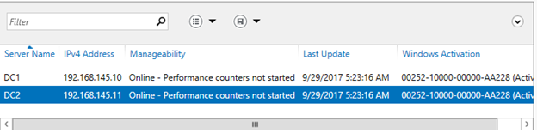

You run through the wizard just as before. In Lab 8a.

Under roles, check the box for DHCP. Click next and click through the remaining windows accepting the defaults.

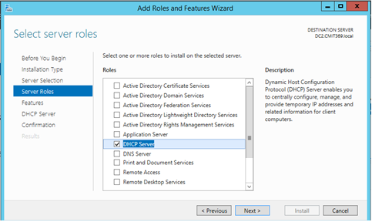

Click install.

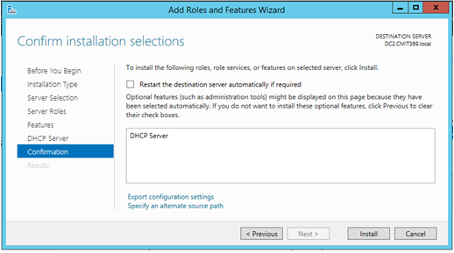

Click close.

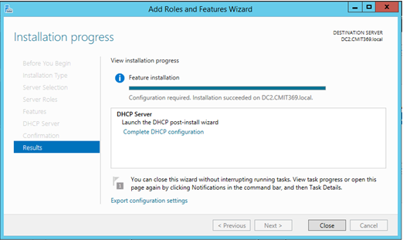

Come back to the Server Manager home page and from the taskbar, click on the yellow warning flag. Click on the link labeled Complete the DHCP Configuration. This starts the DHCP Post-Install Configuration Wizard.

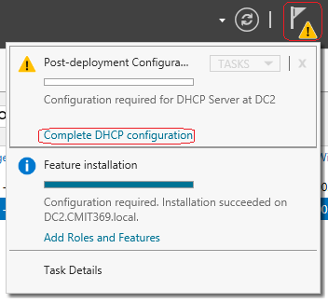

Click next.

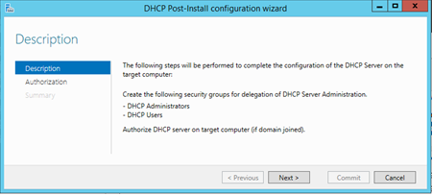

Confirm the credentials used to authorize this DHCP server in AD DS. Click Commit.

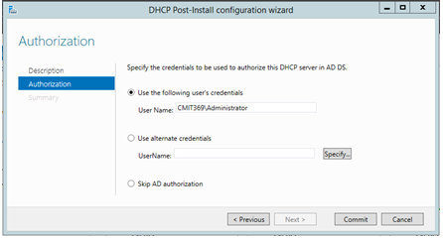

From Server Manager, click on Tools and select the DHCP snap-in from the context menu.

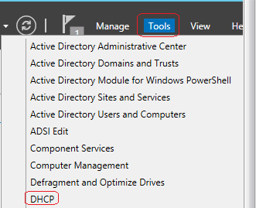

In the DHCP management console, in the left window pane, right click on the DHCP and select Add Server from the top of the context menu.

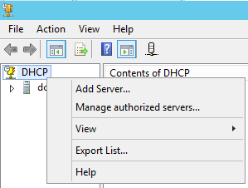

In the Add Server window, Click the radio button for, “This authorized DHCP Server.”

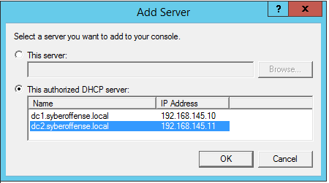

Click the OK button.

You now have two DHCP servers inside the DHCP console window.

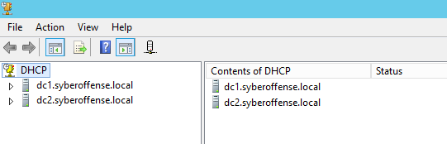

Configure DHCP Failover

Under the name of your first DHCP server (Root DC), expand the IPv4 container. From the context menu select Configure Failover.

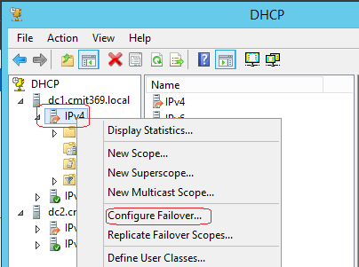

On the Introduction to DHCP Failover page, click Next to allow failover of all DHCP scopes.

Optional: uncheck Select all and select the specific scopes you would like to allow to failover and then click Next.

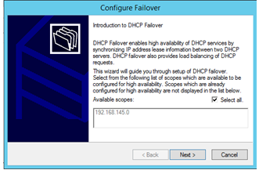

Click on the ****Add Server**** button

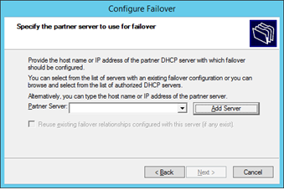

Check the radio button for This authorized DHCP server, select the server you would like to use to allow failover, and then click OK. This will be your Server Core.

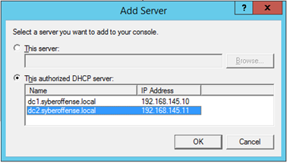

Click Next.

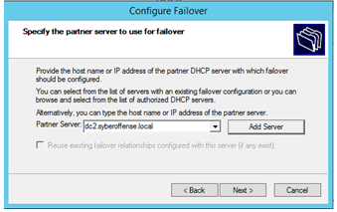

Everything but shared secret and State Failover Interval is done for us.

Some best practices:

If you are failing over in on the same subnet, set up load balancing.  If you are failing is on another network, set the mode to Hot Standby.

* Relationship Name: Descriptive name to describe this DHCP Failover relationship.
* Maximum Client Lead Time: Specifies the amount of time for which a DHCP lease may be renewed by either failover peer without contacting the other.  It also specifies the amount of time that either DHCP server will wait in a “partner down” state before assuming control of the entire IP address range within the scope.  (default = 1 hour).
* Mode: Select Load Balance (default – Active / Active) or Hot Standby (Active / Passive)
* Load Balance Percentage: Specifies the percentage of the IP Address range to reserve for each server in the failover relationship.  Each server will use their assigned range of addresses prior to assuming control over the entire IP Address range of the scope when the other server transitions into a “partner down” state and the Maximum Client Lead Time (specified above) passes.
* Auto State Switchover Interval: When selected, specifies the amount of time that elapses before a DHCP Server is automatically transitioned to a “partner down” state when network communication is interrupted to a DHCP Server.  If this option is unchecked, an administrator must manually transition the status of a DHCP Server into a “partner down” state using the *DHCP Management* console or PowerShell. (when checked, the default = 60 minutes)
* Enable Message Authentication: check this checkbox option to enable authentication of failover replication traffic between servers
* Shared Secret:  Type a “Shared Secret” (i.e.., a Password) to be used to authenticate the failover connection between servers

Click Next.

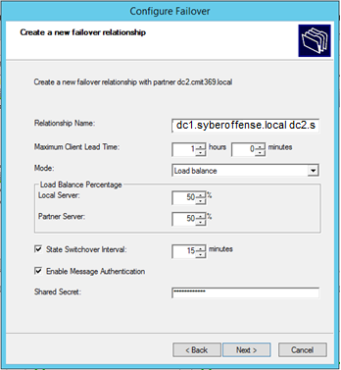

Click Finish.

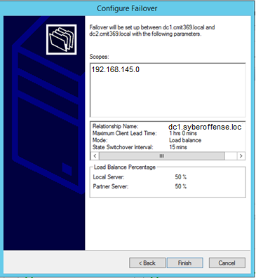

Click Close.

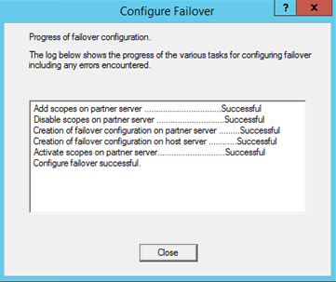

To confirm that failover is enabled on your Server Core, expand and right click on the IPv4 container beneath your Server Core and from the context menu select Properties.

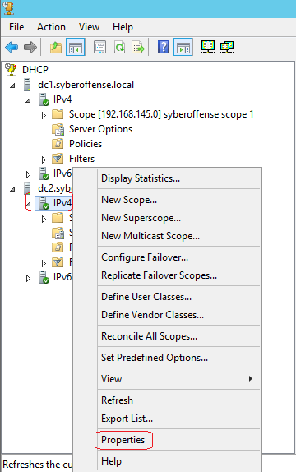

Click on the failover tab and confirm your failover relationship with your main DHCP server.

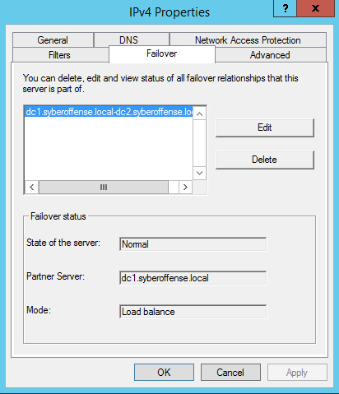

End of the lab!